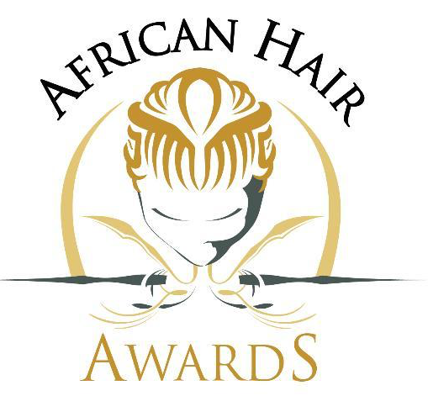

ANNUAL AFRICAN HAIR AWARDS

CATEGORY - CHEMICAL RELAXER PRODUCT RANGE

Please note:
- The below gives you advance knowledge of the questions that need to be answered in full.

- Please ensure the declarations and model release forms (below) are filled out, All photographic images and samples should reach us on the indicated dates.

- Please ensure you read and sign the entire general Awards Rules and Regulations document and your specific category rules and criteria before commencing any of your entry.

- The Total Questions is out of 100 you need to score 80% to qualify to be nominated in the 2016 African Hair Awards

Question 1 (10 points)

In no more than 150 words describe how you earn the right to be awarded this title.
__________________________________________________________________

Question 2 (30 Points)
In no more than 200 words How long has your brand/product been in the industry? How has your product impacted the lives of consumers and the industry as a whole?
___________________________________________________________________

Question 3 (25 Points)
List up to 10 career/product/brand highlights and activities of your Brand/Product
__________________________________________________________________

Question 4 (15 Points)
Briefly describe your Brand/Product Safety Standards (100 words)
__________________________________________________________________

Question 5 (20 Points)
Where is your brand currently available, distributed and Available (150 words)
___________________________________________________________________

_____________________ ___________________ __________________
SUBMITTED BY DATE SIGNATURE

_____________________ __________________ ___________________
RECEIVED BY DATE SIGNATURE

